votre lettre du
vos rÉf.

nos rÉf.
date 20/08/2008

annexe(s)

contact Jean Pottier
tÉl. 02/524 73 62
fax 02/524 73 99
e-mail jean.pottier@health.fgov.be
objet Request clarification article 4.2 a) & b)
direction-générale
Animaux, Végétaux et Alimentation

Service
Denrées Alimentaires, Aliments pour animaux et
Autres Produits de Consommation
Christophe Didion
European Commission
DG Sancos

Dear Mr. Didion,

With regard to regulation 1924/2006 on nutrition and health claims made on foods, Belgium would like to add the interpretation of article 4.2 a) and b) (derogations from nutrient profiles) on the agenda of next meeting of the working group on September the 5th.

Projects to reformulate the composition of food products require in certain cases long-term research programmes. In addition, investments in modifications of production facilities are sometimes necessary. It is therefore important for food business operators to know as early as possible under which conditions claims will be allowed.

You will find hereunder some cases with Belgium’s interpretation of article 4.2 a) and b). We would appreciate the opportunity to discuss them with the Commission and Member States.

We hope that this issue could be definitively settled at the latest when the nutrient profiles are adopted, at the beginning of next year.

Yours sincerely,

Jean Pottier

- Product reduced in salt, but still too high in salt in comparison with the profiles:  → “salt reduced” – no statement | 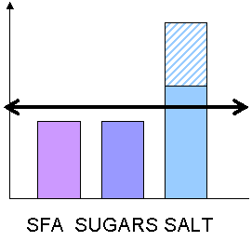
According to the first derogation (4.2-a), the claim “salt reduced” can be made without reference to the profile for salt. Since the salt profile does not need to be taken into account, no profile must be regarded as exceeded and therefore no statement is required (4.2-b).
__________________________

- Product reduced in saturated fatty acids (SFA) and salt , but still too high in SFA and salt in comparison with the profiles:  → “SFA reduced” – “salt reduced” – no statement | 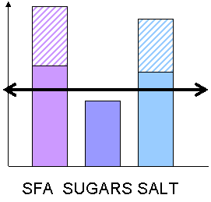
According to the first derogation (4.2-a), the SFA and salt profiles do not need to be taken into account. The claims “SFA reduced” and “salt reduced” can be made without any statement.
__________________________

- Product reduced in salt, but still too high in salt, and too high in SFA in comparison with the profiles:  → “salt reduced” – “high SFA content” | 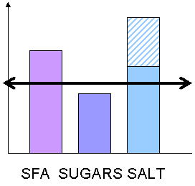
According to the first derogation (4.2-a), the claim “salt reduced” can be made without reference to the profile for salt. Since the salt profile does not need to be taken into account, no statement on salt is required.
However, according to article 4.2-b, a statement on SFA is required since a claim is made (“salt reduced”) and one nutrient exceeds the profiles (SFA).
__________________________

- Product reduced in SFA and salt , but still too high in SFA and salt, and too high in sugars in comparison with the profiles:  → “SFA reduced” – “salt reduced” – “high sugars content” | 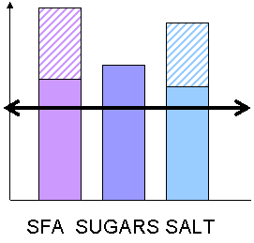
According to the first derogation (4.2-a), the SFA and salt profiles do not need to be taken into account. The claims “SFA reduced” and “salt reduced” can be made, but with a statement on sugars since claims are made and one nutrient exceeds the profiles.
__________________________

- Product reduced in salt, but still too high in salt, and too high in SFA and sugars in comparison with the profiles:  → no claim allowed | 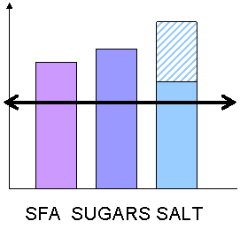
According to the first derogation (4.2-a), the salt profile does not need to be taken into account. However, two other profiles are exceeded. Therefore, no claim is allowed (not even “salt reduced”).
__________________________

- Product with calcium, but too high in salt in comparison with the profiles:  → “source of Ca” – “high salt content” | 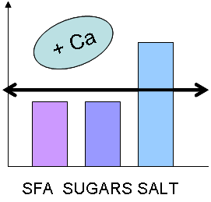
According to article 4.2-b, the claim on calcium can be made since only a single nutrient exceeds the profiles, provided that a statement on this nutrient is added.
__________________________

- Product with calcium, but too high in salt and SFA in comparison with the profiles:  → no claim allowed | 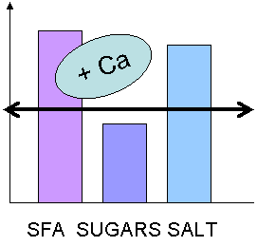
No claim is allowed since two nutrients exceed the profiles.
__________________________

- Product with calcium, reduced in salt, but still too high in salt in comparison with the profiles:  → “salt reduced” - “source of Ca” – no statement | 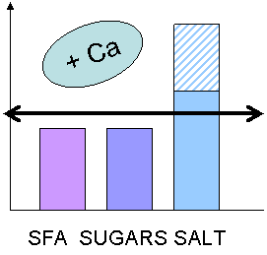
According to the first derogation (4.2-a), the salt profile does not need to be taken into account. Since no other profile is exceeded, no statement is required for the claim “source of Ca”.
__________________________

- Product with calcium, reduced in SFA and salt, but still too high in SFA and salt in comparison with the profiles:  → “SFA reduced” - “salt reduced” - “source of Ca” | 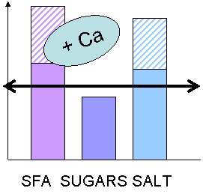
According to the first derogation (4.2-a), the SFA and salt profiles do not need to be taken into account. No statement is required for the claim “source of Ca” since no other profile is exceeded.
__________________________

- Product with calcium, reduced in salt, but still too high in salt and too high in SFA in comparison with the profiles:  → “salt reduced” - “source of Ca” – “high SFA content” | 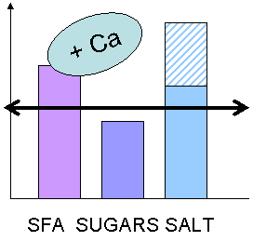
According to the first derogation (4.2-a), the salt profile does not need to be taken into account. However, the SFA content exceeds the profiles. Therefore, a statement on SFA is required.
__________________________

- Product with calcium, reduced in SFA and salt, but still too high in SFA and salt, and too high in sugars in comparison with the profiles:  → “SFA reduced” - “salt reduced” - “source of Ca” - “high sugar content” | 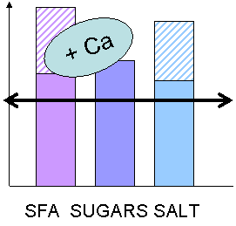
According to the first derogation (4.2-a), the SFA and salt profiles do not need to be taken into account.
However, the sugar content exceeds the profiles. Therefore, a statement on sugars is required.
__________________________

- Product with calcium, reduced in salt, but still too high in salt, and too high in SAF and sugars in comparison with the profiles:  → no claim allowed | 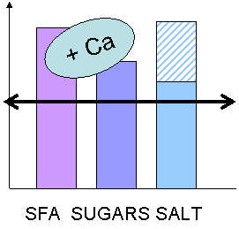
According to the first derogation (4.2-a), the salt profile does not need to be taken into account.
However, two other profiles are exceeded. Therefore, no claim is allowed (not even “salt reduced”).
__________________________

